PROJECT PROPOSAL
DREAM VILLAGE
to Kanthari Foundation Switzerland
Name of social venture: DREAM VILLAGE:
Gasabo Distinct
Kigali Municipality
Rwanda
Email: dreamvillage8@gmail.com
Phone: +250-786816358
Website: www.dreamvillage.rw.org

PROJECT PROPOSAL DREAM VILLAGE
BACKGROUND OF DREAM VILLAGE:
Dream village is a National Ngo registered in Gasabo District in Kigali Rwanda. It runs a one year empowerment program that builds the capacity of HIV Positive young adults and youth to reach their full potential. It aims to make them have a positive and sustainable impact to the society whereby; they can realize and nurture their visions and dreams in life. The end result is to empower them become positive ambassadors for people living with HIV who demonstrate the power of surviving against all odds, a generation that takes their own problems and solutions in their own hands. This will reduce stigmatization and promote self confidence. These empowered young adolescents and youth will start social projects in their communities thus being active partners rather than passive recipients since as survivors; they have overcome many huddles in life. This one year program is based on the kanthari leadership program for social change (www.kanthari.org). Presently, Dream Village has trained 10 participants that are already running their ventures and we intend to train 15 this year 2017.

1. PROBLEM DEFINITION
The HIV/AIDS pandemic represents potentially one of the most disruptive threats to Rwanda’s social and economic development. While HIV/AIDS was once considered mostly a "health" problem, policy-makers in Rwanda increasingly acknowledge that HIV/AIDS is wreaking havoc on the economy as well as on an ever-widening portion of the population. The Rwandan genocide of 1994 increased the risk of HIV infection as thousands of survivors contracted the virus as a result of systematic sexual violence and rape against girls and women. 21 years today after the genocide, its estimated that over 210,000 people are HIV positive out of the 12million total population. (UNAIDS 2014).
In spite of this reality, most service delivery programs by the government have no holistic and sustainable interventions to address this issue. The HIV young adults are sidelined, stigmatized, as many believe that it’s not worth investing in them. Even with the success treatment of antiretroviral therapy (ART), most communities and people still think they have low life expectancy and will die soon. They are still treated as objects for charity, and burdens of the society. This has created a scenario where young adults continue to see HIV as a death sentence.
A case in point is a cousin of mine who some months back, committed suicide after being found positive. He foresaw the stigmatization that waited for him. That’s the nature of depression, anxiety, suicidal thoughts that are common among young adults living positively as they suffer with issues of self-confidence or trying to look for acceptance. The ideal is that once one is found HIV positive, it’s a death sentence and in most cases has no one to lean on.
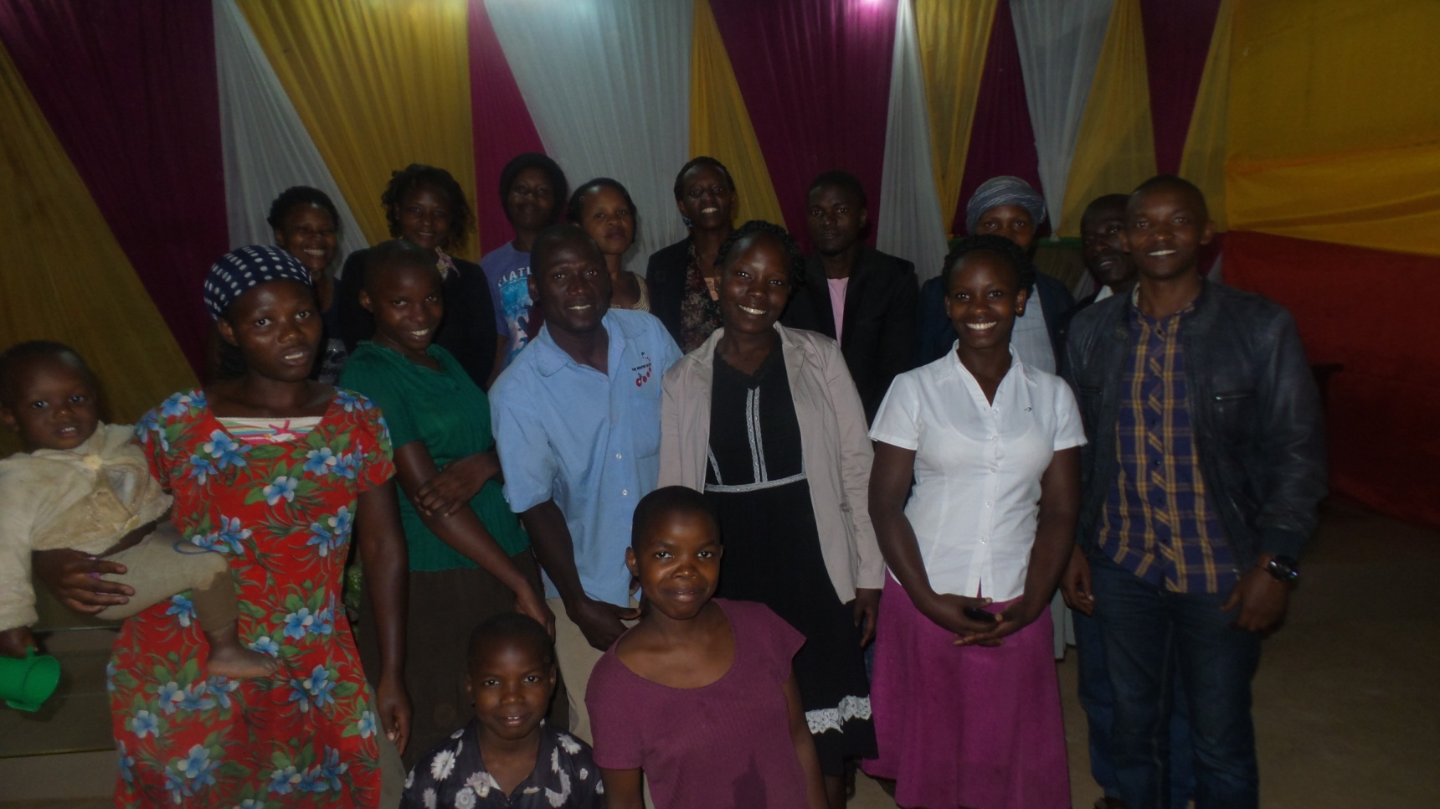
With the concept of dream village, it is flexible concept that open to modification and tailored for the needs of each program for our participants. This is an area that is essential and is in high demand. a lot of Ngos in the world and Rwanda are trying to run portions of it somehow, but not many are successful. Thus we were the first of its kind. Dream village long term objective is to enable the HIV positive young adults and youth realize their dreams and dare I say, unlocking their full potential, and swim against the flow of charity and institutional model. There is need and lots of opportunity to create a unique expedition in Rwanda for leaders living positively with HIV.
We started in Kigali municipality which has the highest numbers of HIV positive young adults in the three district the provinces of Rwanda. (HIV/AIDS Annual Report 2010-2011/2012) but we are scaling up the whole country and East Africa.
2. SOLUTION
I dream of a Rwanda in which people who are HIV positive, are seen as change agents and not as objects of charity. To achieve this I provide a centre in which people living with HIV are empowered to create positive social change. This centre runs a one year empowerment program that will build the capacity of HIV Positive young adults to reach their full potential. They will have a positive and sustainable impact to the society whereby, they can realize and nurture their visions and dreams in life. They will become positive ambassadors for people living with HIV who demonstrate the power of surviving against all odds. It will become a generation that takes their own problems and solutions in their own hands. This will reduce stigmatization and promote self confidence. These empowered young adults and youth will start social projects in their communities. This will see them being active partners rather than passive recipients since as survivors, they have overcome many huddles in life.
This one year program is based on the kanthari leadership program for social change (www.kanthari.org). Our students are equipped with necessary skills such as interpersonal speech and communication, fundraising, project management, Accounting and finance, Business for social change, legal matters (how to start an organization in their societies), confidence building, entrepreneurship, social issues campaign and awareness, social project branding, curriculum training and development, book keeping, working with the media, social marketing, problem solving and decision making. This prepares them to be the change agents of Rwanda. To achieve this, dream village runs a program divided into four themes:

Theme 1: Psychosocial support- (learning to overcome self-stigmatization)
Theme 2: Dare to Dream. – (Personal Development)
Theme 3: Dare to Live –(Ready to take up HIV initiatives and start projects in their the society)
Theme 4: Mentoring - (Participants will have started their social ventures and are being guided through the first big waves and issues.)
PROPOSED PROJECT:
Construction of an eco-friendly and cost effective training Centre:

Dream village runs trainings for the HIV Positive youth and young adults annually, however it always spends a lot of funds on hiring training centre which at most times affects even the number of participants to be trained. We therefore wish to use 5000 USD towards construction of an eco-friendly and cost effective training centre. The constructed centre will reduce on such costs, will lead to an increase on the number of participants to be trained since we shall have an adequate place that is accessible to a big number and in the long run, the centre will be a fundraising project for the venture where by the hall can be hired out for meetings, weddings even to other NGOs,and companies that wish to make training from our unique and eco-friendly centre.. The land where the centre will be built belongs to Dream village as an organization. This will create sustainability of our organization as an alternative source of income of which the funds received can be converted into scholarships for supporting more HIV positive young adults and youth will be applying to attend our trainings.

Particulars of the training centre:

The training centre will be a unique eco friendly and cost effective centre that will be the first of its kind in Rwanda. It will have some of the following features
Rain water harvesting system
Natural and fresh water conditioning
Solar and wind energy
Ecosan toilet system
Ant ant channels
Low consumption solar LED lights
Low cost construction materials like mud
Biogas syatem
Composit production
Bio vegetable cultivation.
This uniqueness will further make us a one stop centre where other NGOS, designers and academicians can learn from and all visitors will have a chance to learn about what we do which in the long run will expand our networks as well as attracting parteners to work with us on our programs.

Activity | Out put | Time frame | P/Responsible | Risk/ mitigation | Resources
Making office/training centre construction plan. | Training centre plan obtained. | Feb 17 | director | Failure to get the best planner/ networking with the district to get the best planner for the accepted plan. | Fee for the centre plan.
Acquiring the office construction license from district land commission | Construction license obtained. | Feb 17 | Director/ board chairperson | Delay in obtaining a construction license at the district/ constant follow up with the district land commission to acquire a license timely. | Airtime  Time  transport
Clearing the ground for construction | Cleaned ground ready for starting to construction | March 17 | Board members | Board members being busy to be around/ timely communication in the meetings so as responsibility is delegated. | Man power  Time
Fencing the construction site | Construction centre fenced. | March 17 | Board members | Board members being busy to be around/ timely communication in the meetings so as responsibility is delegated. | Personnel, airtime  Fencing mesh.
Constructing a temporary structure for storage building materials like cement and accommodating builders. | A temporary store structure constructed. | March 17 | Director. | Failure to get second hand materials to use/ networking with other building sites to acquire them at an affordable rate. | Funds,  Personnel  Airtime  Time
Carrying materials to the site like bricks, sand, cement. | Building materials purchased and dropped at construction centre | March 17 | Director/ board members | Prices rising up from the budgeted ones/ making agreements with few sellers that will not hike prices | Airtime, personnel, venue  Funds for builder
Starting on construction-dam course | First phase of construction started | March 17 | Board members | Builder failing to come as agreed/ constant communication with builder | Builder fee, water, time
Starting on the second phrase ( to wall plate.) | Second phrase finished( wall plate) | April 17 | Board members. | Materials lacking than planned./ following with the budget. | Builder fee  Time
Roofing and shuttling the training centre | Training centre roofed and shutters put in place | April 2017 | Site engineer, director | Failure to be in schedule due to genocide commemoration/ working at the available days hard to compensate to the others. | Shutter  Iron sheets  Time.
Working on the ceiling of the training centre. | Ceiling of the training centre done | May 17 | Site engineer  Board members | Failure to have the ceiling materials in time./ timely purchasing for the items | Timber  Ceiling materials  Time.
Plastering and tiling the centre. | Training centre tiled and plastered | May 17 | Site engineer | Failure to have the materials in time./ timely purchasing for the items | Cement  Sand  Time  Personnel
Painting and fixing glasses | Training centre painted and glasses fitted. | June 17 | Site engineer/ director. | Failure to have the materials in time./ timely purchasing for the items | Glasses  Paint  Personnel.
Leveling the compound | Compound leveled. | June 17 | Director/ board members. | Rainy season making hard to level the compound/planning earlier before the rainy season. | Personnel
Official opening of the training centre. | Training centre officially opened | July 17 | Board chairperson. | Date getting caught up in another national function,/ prior preparation and consultation. | Time  Personnel

DREAM VILLAGE CONSTRUCTION BUDGET:
 | DREAM VILLAGE TRAINING CENTRE BUDGET:
for Period: 28 days
exchange rate: |  |  | 1 | US $ | 800 |  | RWF
as of: | 22nd /2/2017
 | TRAINING CENTRE
No | Cost | Freq | Units | unit Price | Total Cost (RWF) | Unit Price $ | Total Cost (US)
1 | Building plan | 1 | 1 | 100,000 RWF | 100,000 RWF | $125 | $125.00
2 | Building license | 1 | 1 | 60,000 RWF | 60,000 RWF | $75 | $75.00
3 | Preparing building place | 1 | 20 | 2,500 RWF | 50,000 RWF | $3 | $62.50
4 | Tape for foundation measuring | 1 | 3 | 300 RWF | 900 RWF | $0 | $1.13
5 | Madrier(Foundation timber) | 1 | 3 | 3,000 RWF | 9,000 RWF | $4 | $11.25
6 | Concrete stones | 1 | 8 | 50,000 RWF | 400,000 RWF | $63 | $500.00
7 | Sand | 1 | 5 | 50,000 RWF | 250,000 RWF | $63 | $312.50
8 | Cement | 1 | 40 | 20,000 RWF | 800,000 RWF | $25 | $1,000.00
9 | Dam course Roofing | 1 | 4 | 20,000 RWF | 80,000 RWF | $25 | $100.00
10 | Gravier | 1 | 1 | 80,000 RWF | 80,000 RWF | $100 | $100.00
11 | Iron bars | 1 | 20 | 10,000 RWF | 200,000 RWF | $13 | $250.00
12 | labour for construction | 1 | 1 | 300,000 RWF | 300,000 RWF | $375 | $375.00
13 | Transport for materials | 1 | 3 | 70,000 RWF | 210,000 RWF | $88 | $262.50
14 | Crostat | 1 | 1 | 31,200 RWF | 31,200 RWF | $39 | $39.00
15 | Water | 1 | 400 | 300 RWF | 40,000 RWF | $0 | $50.00
16 | Brocks | 1 | 2000 | 600 RWF | 1,200,000 RWF | $1 | $1,500.00
17 | Small concrete stones | 1 | 3 | 60,000 RWF | 180,000 RWF | $75 | $225.00
18 | Nails | 1 | 3 | 3,000 RWF | 9,000 RWF | $4 | $11.25
 | TOTAL EXPENSES |  |  |  | 4,465,000 RWF | $0 | $5,000.13

NOTES ABOUT THE BUDGET AND OTHER INFORMATION .
(a)Particulars of the training centre:

1. A training hall of 40 people sitting capacity with two washrooms

2. I office with a washroom for the staff

3. 2 other rooms self contained which could be used as part accommodating a few participants during trainings.

4. 1 small kitchen attached for meals preparation during trainings, workshops and meetings.

(b) These estimates cover all the foundation costs and part of the elevation level.
(c) The estimates are picked from the market price as of 22nd Feb 2017
(d)1 and 2: For the government to allow one to build in Rwanda, he /she needs to have a plan and license approved by District land authorities in the district where the construction will take place
(e) The training centre will be constructed in Gasabo district, Kigali city municipality Rwanda.

BANK DETAILS

Name of Bank and Branch: Cogebanque ltd, Remera Branch.
Account Name: Dream Village.
Account Number: 0040139013085816
SWIFT/ BIC Numbers; CGBK RW RW
Address of Bank: Centenary House KN4 Av and 72ST, BP 5230, Kigali- Rwanda.
Telephone number of Bank: (+250) 252597500 Main Branch
(+250) 252597564 Remera Branch
Email address of Bank: cogebank@cogebank.com

Address account Holder: God is able House KN5 Avenue, Remera, Gasabo, Kigali- Rwanda.
Tel Number account Holder: +250786816358
Name of Intermediary Bank & Branch: ING Belgium
Account Name: Cogebanque (Compagnie Generale de Banque)
Account Number: 301-0102850-14
SWIFT/ BIC Numbers; BBRUBEBB
IBAN Number BE 94301-0102850-14
Address of Bank:

