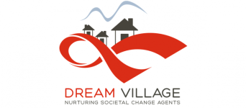
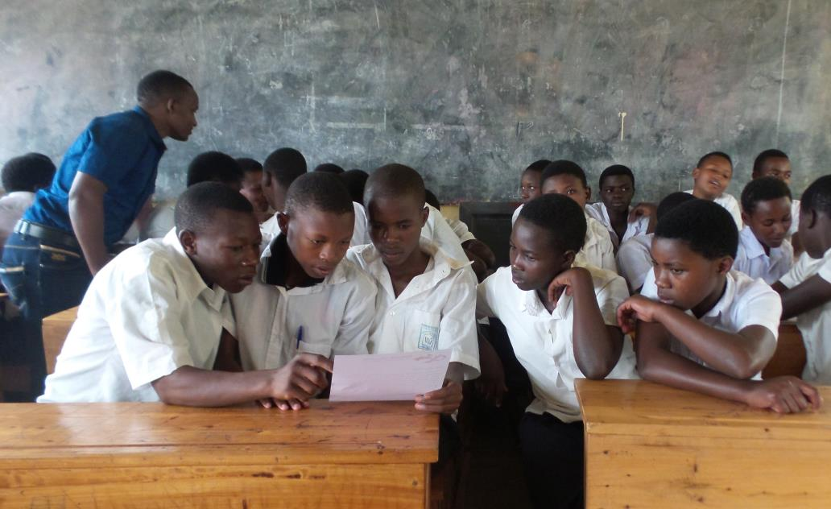

Introduction to DREAM VILLAGE, Rwanda:
Dream village is a National Ngo registered in Gasabo District in Kigali Rwanda.
It runs a one year empowerment program that builds the capacity of HIV Positive young adults and youth to reach their full potential.
It aims to make them have a positive and sustainable impact to the society whereby they can realize and nurture their visions and dreams in life.
The end result is to empower them become positive ambassadors for people living with HIV who demonstrate the power of surviving against all odds, a generation that takes their problems and solutions in their own hands. This will reduce stigmatization and promote self confidence.
These empowered young adolescents and youth will start social projects in their communities thus being active partners rather than passive recipients since as survivors; they have overcome many hurdles in life. This one year program is based on the kanthari leadership program for social change (www.kanthari.org).
Furthermore, Dream village short courses that equip small local community based organizations, institutions and persons who want to work in the HIV filed as well as enhancing HIV expertise knowledge for those already working in the same field. Below are some of the projects we have run.
1. Since 2016, dream village has trained 45 youth of which 15 have started projects in Rwanda. These projects range from working with HIV positive women, youth, children, skill development projects for HIV positive people, agriculture among others.
2. Ten Post test clubs in 10 schools in the districts of Nyarugenge, Gasabo and Kicukiro on positive living campaigns to be scaled up in their respective schools. Each club has about 40 students and this was aimed at giving an understanding on the HIV positive concept rather than the prevention strategy that they had been used to.
3. Ten youth became peer educators in the rural areas on the HIV /AIDS programs. This program targeted 10 youth. With was done with the support of the ministry of health .These youth presently are attached to the local health centres of Nyaruguru, Nyamagabe, Huye, Nyanza districts of Rwanda and are supporting people living positively with HIV/AIDS and training more peer educators.
4. Seven projects of ‘compassion international’ each with 4 staff and 8 volunteers were trained on how they can work with children and their caregivers facing trauma of HIV /AIDS. More staff will be trained in 2018
5. Four youth groups from churches in Kigali under the platform of religious council have been trained on positive living. This was aimed at counteracting the religious silence on HIV/AIDS in most religious sections yet it s a challenge that needs a holistic approach (each youth group consists of 25 members)
TESTIMONIES OF PARTICIPANTS FROM OUR PREVIOUS TRAININGS.
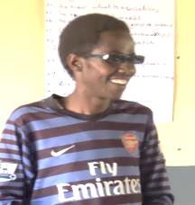
NDIZEYE Alain, one of our participants who got a grenade injury during the genocide and is blind in one eye once confessed in one of the training-:”…. all the time I was in school I was never allowed to talk because I am blind in one eye and HIV positive. I’m happy that today I am standing in front of you and I see how attentive you are. This is my first time to speak in front of people and they listen to me for two minutes… I know you’re not judging me…”
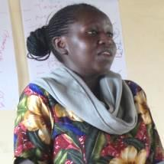
Emmerance UWINGENEYE when asked what she took home from the entire training, said”… my sister had told me that dream village is just like other organizations who tend to use us for their gain. However on the contrary, I have learnt a lot that can sustain my well being like drug adherence. My life has changed mostly the way I think about my future. I now want to change the perception that my sister had about Dream Village, so that she can attend the next training if she is lucky to get a chance...”
BATAMULIZA Valentine another female participant said”…I lived in uncertainty about my future. I dropped out of school because my aunt said there was no money to pay for a dying girl. I have lived every day counting my day. I am not that girl anymore. I feel I can chase any dream in my life. I want to live a life of sharing to other girls like me who have faced hopelessness. It’s by Gods will that dream village was able to identify me.”

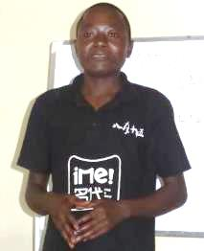
Alphonse had this to say about his time at Dream village”… when I was born, my dying father named Ukwizagira( literally meaning the way he will do it), he knew I would follow him to the grave in the shortest possible time. However, I managed to live either by luck or by the grace of God. Either way, I have been knowing any day I will die due to my body function failing to function due to weak immunity or in my sleep. I had no plan for the future, I am happy to know that I can live for as many years as possible like any other person if I adhere to my medication… and I will do so…”

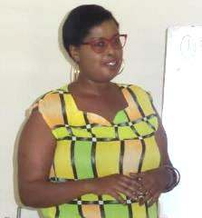
Olive said”… when my husband and child died, I never knew anything until I started falling sick myself. After that I was depressed and was referred to the mental hospital where I had to take drugs for people with a mental challenge for so many years. My turning point was in January 2017 when a person named Morris who was trained by dream village in 2016 visited us and he said my problem was the silence that was eating me. He recommended me here as a platform that I would open up whatever has been eating me…. I want to say that I have not been disappointed… I have removed the burden that has been eating me. After sharing my life with you, I feel free..”

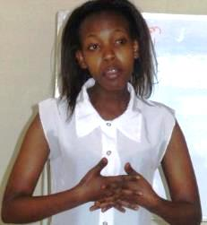
Dianah was asked what it means for her to have attended dream village training and she said” for so many years, I have lived in too much fear. The fear of dying soon. Every morning I would look at my arms and think everybody recognizes that I am HIV positive. I ended up hating everything about me, my friends and greatly my uncle who infected me, I can’t change anything.. However, now that I have learnt on how I can live long adhering to my treatment and most of all knowing that there is a possibility of changing the medication regimen when one fails, I feel strong”

THE PROBLEM
The HIV/AIDS pandemic represents potentially one of the most disruptive threats to Rwanda’s social and economic development. While HIV/AIDS was once considered mostly a "health" problem, policy-makers in Rwanda increasingly acknowledge that HIV/AIDS is wreaking havoc on the economy as well as on an ever-widening portion of the population. The Rwandan genocide of 1994 increased the risk of HIV infection as thousands of survivors contracted the virus as a result of systematic sexual violence and rape against girls and women. Today, 23 years after the genocide, it is estimated that out of a population of 12 million people, over 210,000 people are HIV positive. Most of these are youth and young adults (UNAIDS 2014).

In spite of this reality, most service delivery programs have no holistic and sustainable interventions to address this issue. People living with HIV /Aids are sidelined, stigmatized, as many believe that it’s not worth investing in them. Even with the success treatment of antiretroviral therapy (ART), most communities and people still think they have low life expectancy and will die soon. They are still seen as objects of charity, and burdens to the society. This has created a scenario where people continue to see HIV as a death sentence.

SOLUTION.
I dream of a Rwanda in which people who are HIV positive, are seen as change agents and not as objects of charity. To achieve this dream Village empowers people living with HIV to create positive social change. We run a one year empowerment program that builds the capacity of HIV Positive young adults. We want them to have a sustainable impact to the society whereby they realize and nurture their visions and dreams in life.

PROPOSED PROJECT:
Construction of an eco-friendly and cost effective training Centre:

Dream village runs an annual empowerment training program for HIV Positive youth and young adults and other short courses for the same target group.
Unfortunately, to run such programs we need to rent training halls.
This takes has a negative impact on the effectiveness of funds used, which results in limiting the number of participants to be trained and impacted by our programs.
Our plan is to construct a cost effective and eco-friendly Dream village training centre. This will enable us to scale up on our projects and it will reduce the cost of training.
We wish to accommodate the participants during the training as well as prepare meals at the centre thereby reducing the costs as well as a dependency on restaurants’.
Dream Village owns a piece of land.
I would be grateful to explore possibilities of how Journeyman International and Dream Village could collaborate

I am looking forward to hearing from you.
Thanking you for your interest.

With very best regards,

Manzi Norman

